A Tale of Missed Opportunities: US and Latin America in the Cold War

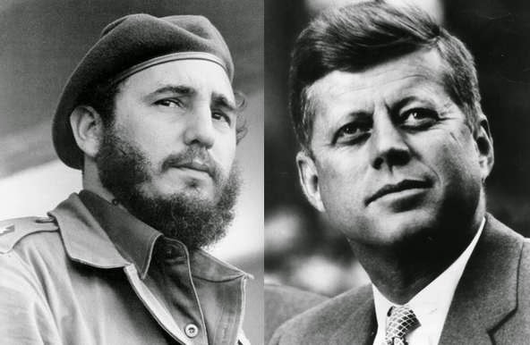

Prof. Rafael R. Ioris (University of Denver)
Invited Professor IHEAL/Fall 2022
Email: rafael.ioris@du.edu
HYSP020
Wednesday, 16h00-18h00
Room 17

Course description and Goals
The Cold War often is interpreted as a conflict between superpowers in a bipolar world. This narrative omits the important histories of non-industrial or developing countries and their relations with core countries along a path where societies in the so-called periphery also exerted agency. Aimed at filling some of these gaps, the present course explores the experiences of Latin America during one of the most important and consequential socio-political, economic, ideological, cultural, and diplomatic contests ever faced by human societies.
Towards doing so, the course will explore, among other things, the motives and outcomes of US government’s actions to counter the perceived Communist threat, as successive administrations expanded intelligence gathering, increased military and economic aid, backed anti-communist government in Latin America, and used US troops in direct military interventions.
Students will engage with materials and learn about the interaction between historical experiences taking place in global, regional, national, and local realities. In addition, participants in the course will develop a general, historically grounded understanding of some of the main events and major interpretations of the Cold War in Latin America. Moreover, by assiduously engaging with class materials and assignments, students will refine their analytical skills, research abilities, historiographical knowledge and narrative expressions.

Course Dynamics
You are expected to keep up with the activities and you are responsible for the material covered in the lectures, readings, and for any announcement made in class. Nevertheless, I do understand that the on-going COVID-19 pandemic has created significant physical and mental health, family, and financial challenges for everyone. I aim to be as flexible as possible while ensuring fairness and academic integrity. If you are struggling with the course for any reason, please talk to me as soon as possible.

Required Readings
- Brands, Hal. Latin America’s Cold War. (Harvard University Press, 2012).
- Harmer, Tanya. Allende’s Chile and the Inter-American Cold War. (University of North Carolina Press, 2014)
- Rabe, Stephen, The Killing Zone: The United States Wages War in Latin America. (Oxford University Press, 2016).
*** Additional readings will be provided by the instructor.

Course Requirements and Evaluation:
Active Participation in Class Discussions and Oral Presentations (20%)
Participation in class requires attending class, demonstrating that you have done all the readings for the class and are ready to share in and contribute to the discussion. Each student will be required to bring a question about the reading assigned for each class meeting and this will set the basis for the discussions of the day. In addition, in specific dates, students will make oral presentations of their midterm and final research papers.

Midterm Paper (5-6 pp, 30% of grade) and Final Paper (7-8 pp, 50% of grade)
These will be research-based papers on a topic of your choosing, upon consultation with the instructor. You will analytically demonstrate your knowledge of an important theme pertaining to the historical evolution helping shape the course of the Cold War in Latin America.
** Details on these assignments will be provided by the instructor in due time.

Schedule of Classes, Readings, and Activities

Personal Introductions & Initial Look (21/09/22)
- Brands, Introduction and Chapter 1
- Pinneo, Recent Cold War Studies (extra reading)

Possible Frames of Analysis – I (28/09/22)
- Dominguez, US in Latin America in the Cold War (extra reading)
- Westad, Intro, Chapters 1 and 2 (extra readings)

Possible Frames of Analysis – II (5/10/22)
- Field, US and the Cold War in Latin America (extra reading)
- Friedman, Retiring the Puppets, Bringing Latin America Back In (extra reading)

Early Years (12/10/22)
- Bethell and Roxborough, Latin America between the Second World War and the Cold War (extra reading)
- Rabe, Chapters 1 and 2

The Radicalization – part I (19/10/22)
- Brands, Chapters 2 and 3
- Rabe, Chapters 3 and 4

Possible Counterpoints? (2/11/22)
- Offiler, The Alliance for Progress (extra reading)
- Pettina, Global Horizons (extra reading)
- Rabe, Chapter 5
- Weis, The Twilight of Pan-Americanism (extra reading)

The Radicalization – part II (9/11/22)
- Brands, Chapters 4 and 5
** Oral Presentation of Midterm Paper & Midterm Paper is due!

Counterinsurgency Gains New Ground (16/11/22)
- Harmer, Chapters 1 to 3
- Rabe, Chapter 6

New Methods and Scope of Intervention (23/11/22)
- Harmer, Chapters 4 to 7

Not in my Backyard: Central America and the New Cold War (30/11/22)
- Brands, Chapters 6 and 7
- Rabe, Chapter 7

How does it End (Does it)? (7/12/22)
- Brands, Chapter 8 and Conclusion
- Rabe, Aftermath

Bringing it all Together (14/12/22)

** Oral Presentation of Final Paper & Final Paper is due!

